# Purpose

This release note covers the changes to Carrier servers to fix ESR mentioned in below table

| ESR | Description | PTC TS # (if any) |
| --- | --- | --- |
| ESR 46173 | Rework Deviation does not have comments | NA |

# Revision History

Link to the document in [http://windchill.carrier.utc.com](http://windchill.carrier.utc.com/) (Carrier’s Production Server).

Carrier: http://windchill.carrier.utc.com/Windchill/app/#ptc1/tcomp/infoPage?oid=VR%3Awt.doc.WTDocument%3A2799577093

# Change History

| Date | Revision | Technician | Description of change and a link to affected section |
| --- | --- | --- | --- |
| 08/06/16 | -.1 | Akhila V Mani | Rework Deviation does not have comments |

# Issue Summary

The CTD Deviation Rework Task does not have comment section. Comments have been included for this ESR.

# Deployment Status

Below table contains current status of these changes, this tables will be updated by Infrastructure Team

|  |  |  |  |
| --- | --- | --- | --- |
| **Servers** | **Development** | **Staging** | **Production** |
| **Deployed by** |  |  |  |
| **Deployed Date** |  |  |  |
| **Validated by** |  |  |  |
| **Validated date** |  |  |  |

# Check List

Below are the lists of items that need to be verified before scheduling deployment on test and production server.

|  |  |  |  |
| --- | --- | --- | --- |
| **Check-list** | **Development** | **Staging** | **Production** |
| **Files updated to SVN** |  |  |  |
| **Included manual recovery steps** |  |  |  |
| **Included validation Steps** |  |  |  |
| **Validation Confirmation from User** |  |  |  |
| **Database Export required** |  |  |  |
| **LDAP Export required?** |  |  |  |
| **Windchill codebase Backup?** |  |  |  |
| **Selected Files Backup** |  |  |  |
| **Change Control** |  |  |  |
| **Windchill Start/Stop required?** |  |  |  |

# Resolution

Below are the different steps involved during deployment.

## Specify the SVN Location

All modified/updated files downloaded from [WCDEV](http://cusnwa5d.carrier.utc.com/wc/wcsvn/branch/WCDEV/) SVN branch

## List of all OOTB & Custom files modified to resolve this issue

Below are the lists of files that are modified to resolve this ESR.

|  |
| --- |
| **File Name** |
| **/apps/ptc/Windchill/loadFiles/ext/carrier/wc/workflows/CarrierCTDDeviationProcess.xml** |

## List of all OOTB and Custom files added to resolve this issue

Below are the lists of files that are added to resolve this ESR.

|  |
| --- |
| **File Name** |

## 7.4 Revision Table

|  |  |  |
| --- | --- | --- |
| **Filename** | **Revision for Change** | **Revision to Restore** |
| **CarrierCTDDeviationProcess** | **2151** | **2143** |

## 7.5 Manual changes before deploying changes

NA

## 7.6 Deployment procedure

1. Download the files mentioned above to their corresponding folders.
2. Load all the files using the following command from Windchill Shell.

**windchill wt.load.LoadFromFile -d /apps/ptc/Windchill/loadFiles/ext/carrier/wc/workflows/CarrierCTDDeviationProcess.xml -u windchill.wcadmin@carrier.utc.com -p utccarrier123 -CONT_PATH \"/wt.inf.container.OrgContainer=Carrier\"**

3. Configure dedicated queue for all required workflows loaded.

4. Stop and Start the server.

# Validation

1. Create Carrier CTD Deviation. In Rework Deviation Task all the comments should be captured.

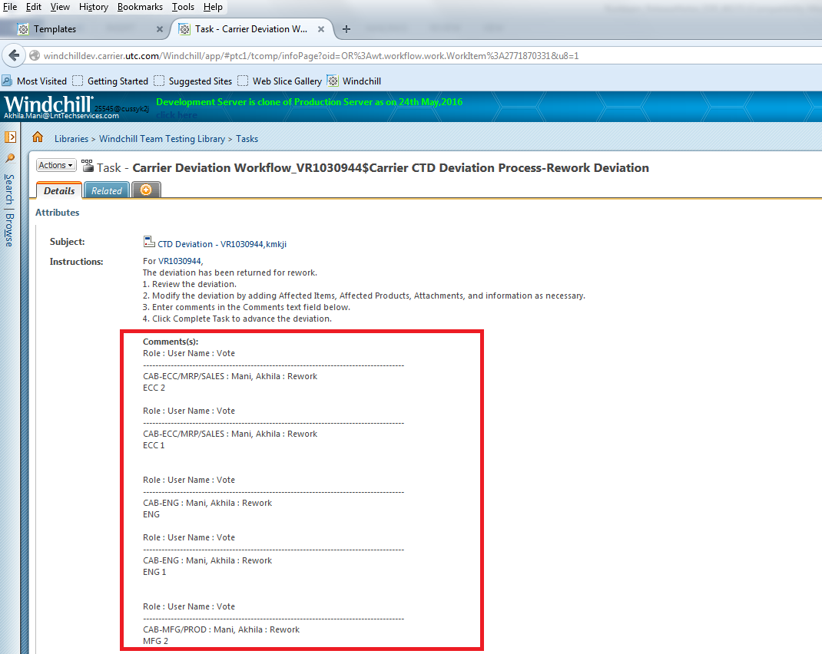

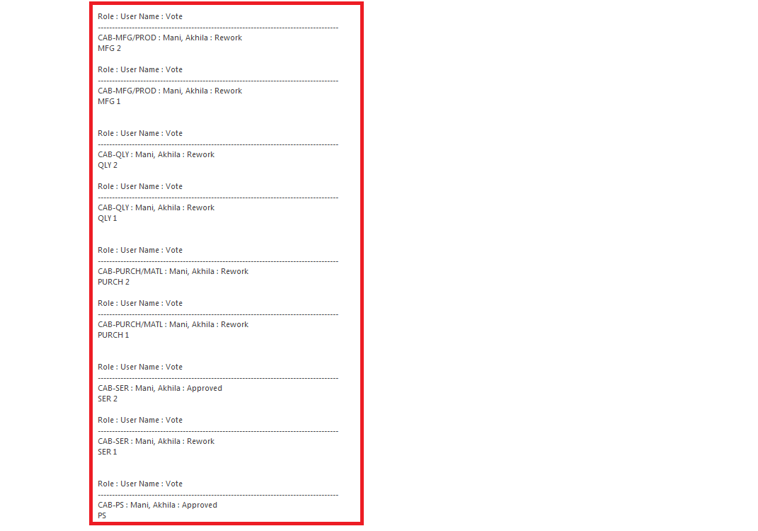

1. User will be sent a notification capturing these comments at Rework Deviation.

Since email is not configured on Development server. Will not be able to test this.

# 9.0 Steps to Restore (On Failure/if Needed)

1. Restore Carrier CTD Deviation Workflow with revision in *Revision to restore* in section 7.4

2. Configure dedicated queue for all required workflow loaded.

3. Stop and Start the server.

# Issues encounter during deployments (If any)

Details of any issues faced during deployment should be captured over here.

# Server Administration procedures

The detailed steps of different server administration procedures are captured and available in Production server administration document available at PDS Site (link) and Carrier site (link).This includes procedures on taking different component backups, stopping and starting different components, steps to clear caches and server restore procedures.

# Contacts

Details of all the contacts who are involved in different phases of deployments will be listed over here.